1.In honor of Valentine 's Day, the bookstore received 10 new books in the genre of "romance”

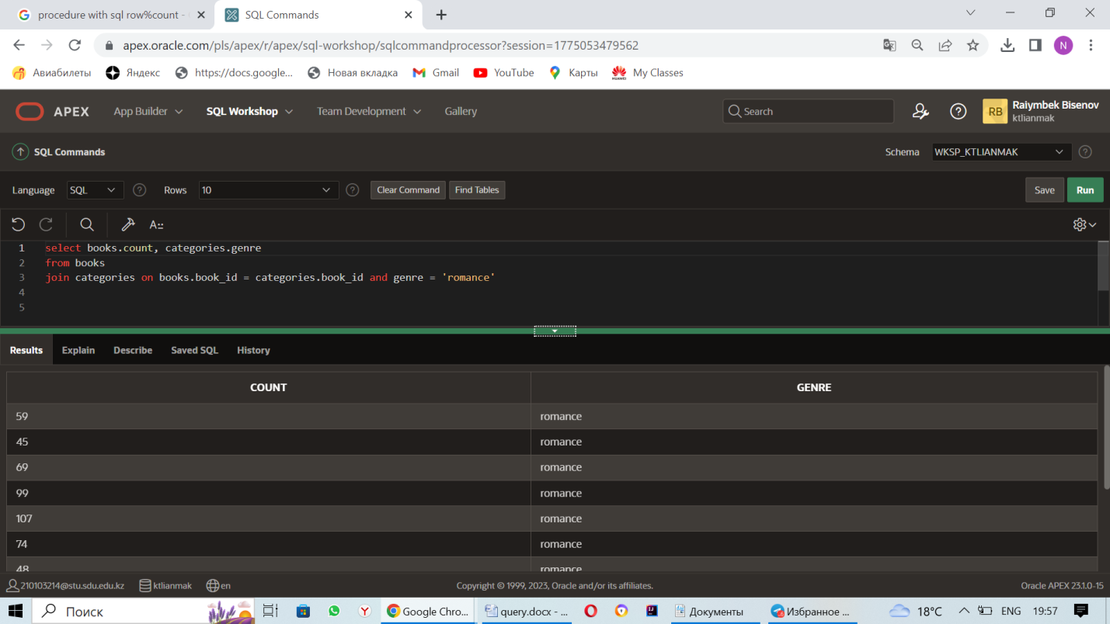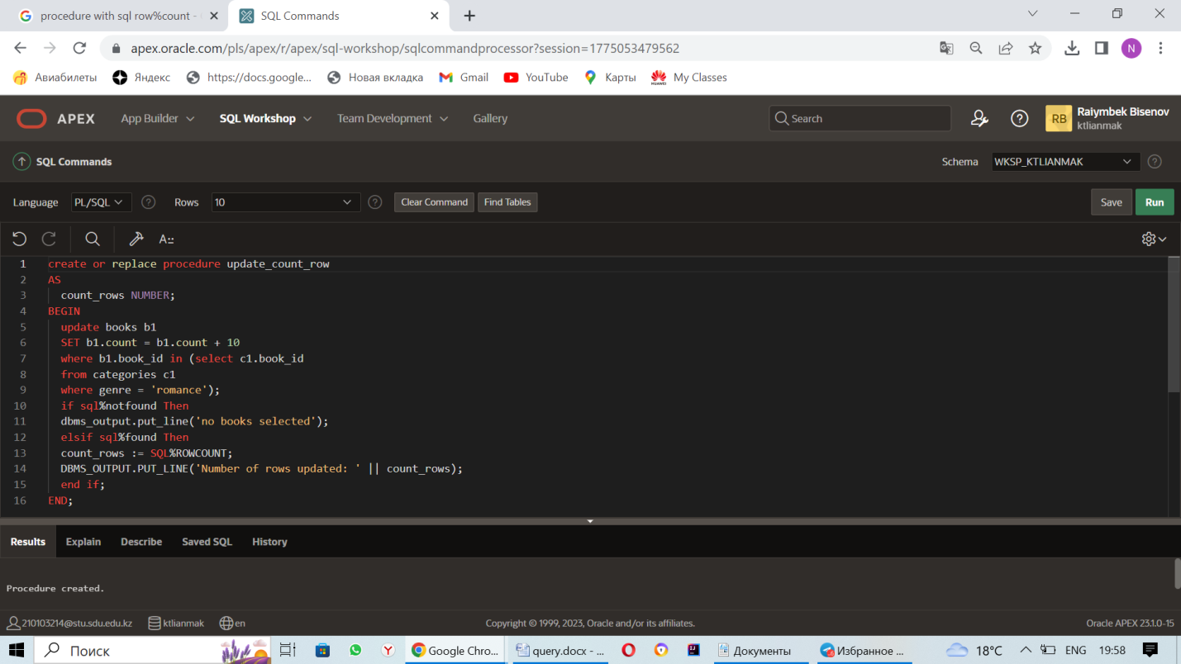

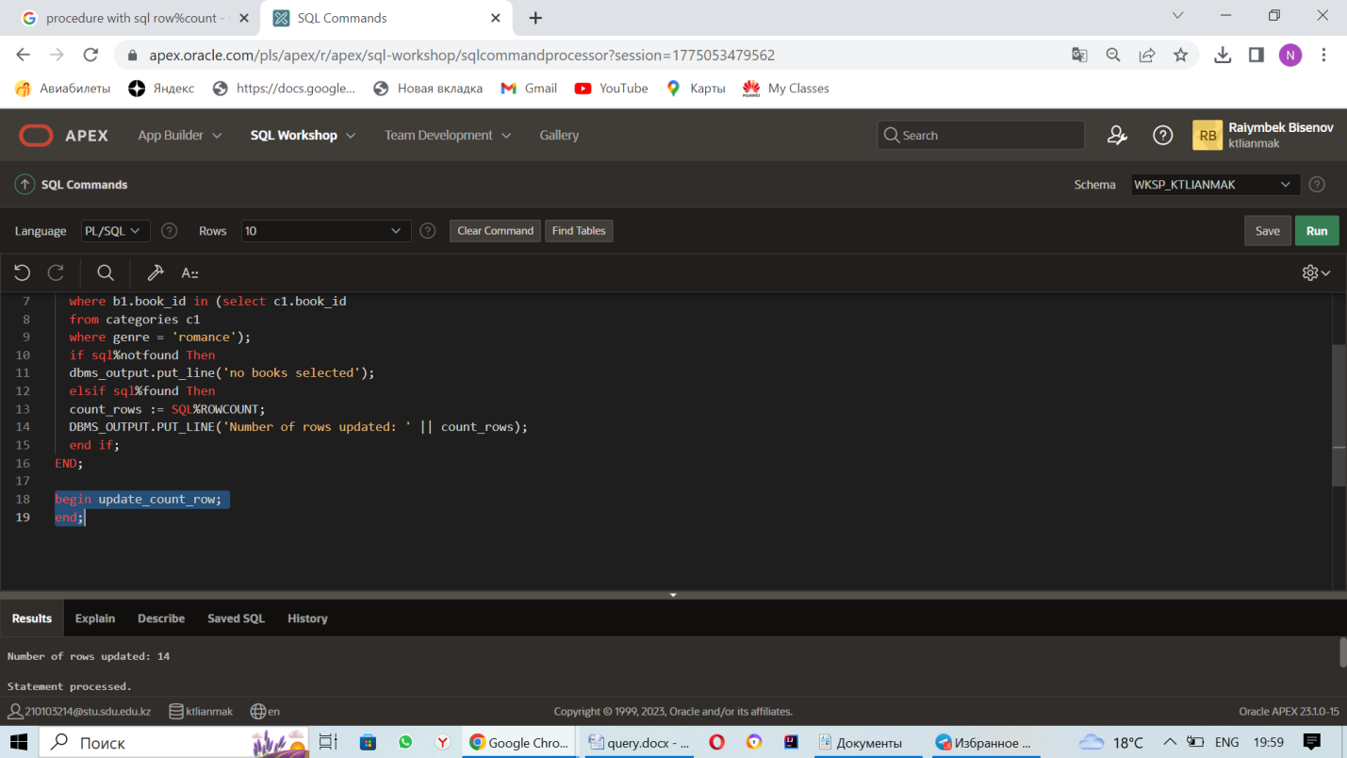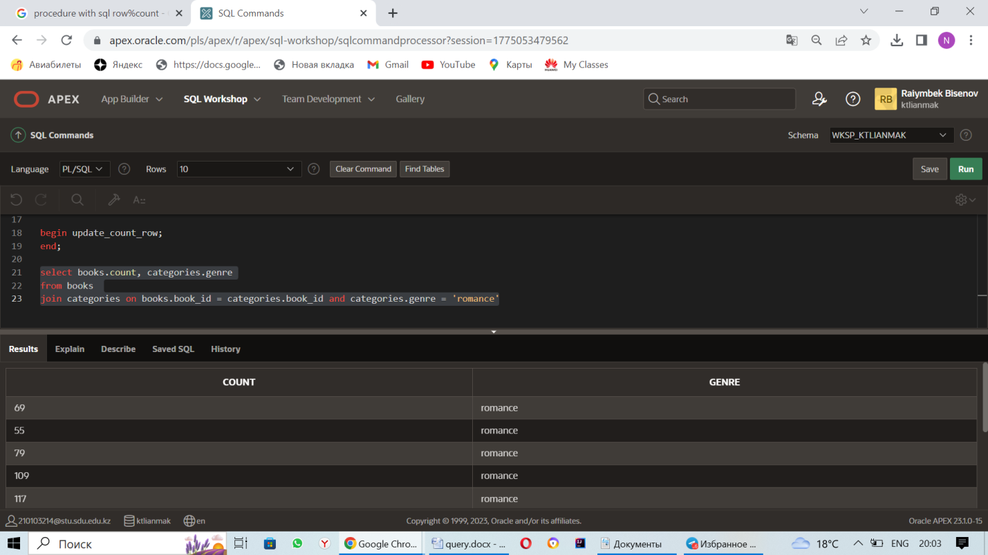

1. Procedure which uses SQL%ROWCOUNT to determine the number of rows affected

create or replace procedure update_count_row

AS

count_rows NUMBER;

BEGIN

update books b1

SET b1.count = b1.count + 10

where b1.book_id in (select c1.book_id

from categories c1

where genre = 'romance');

if sql%notfound Then

dbms_output.put_line('no books selected');

elsif sql%found Then

count_rows := SQL%ROWCOUNT;

DBMS_OUTPUT.PUT_LINE('Number of rows updated: ' || count_rows);

end if;

END;

begin update_count_row;

end;

select books.count, categories.genre

from books

join categories on books.book_id = categories.book_id and categories.genre = 'romance'

2. In our store, if a Customer buys 10 books from the "Reading Child" section. This client will receive a 10% discount on the purchase of 10 books. We need to calculate the total amount. 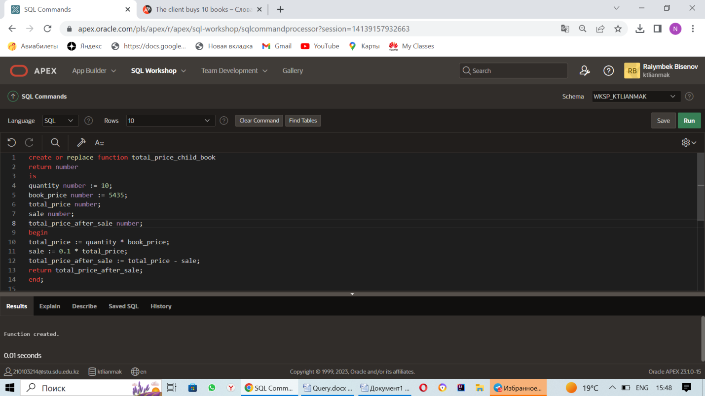

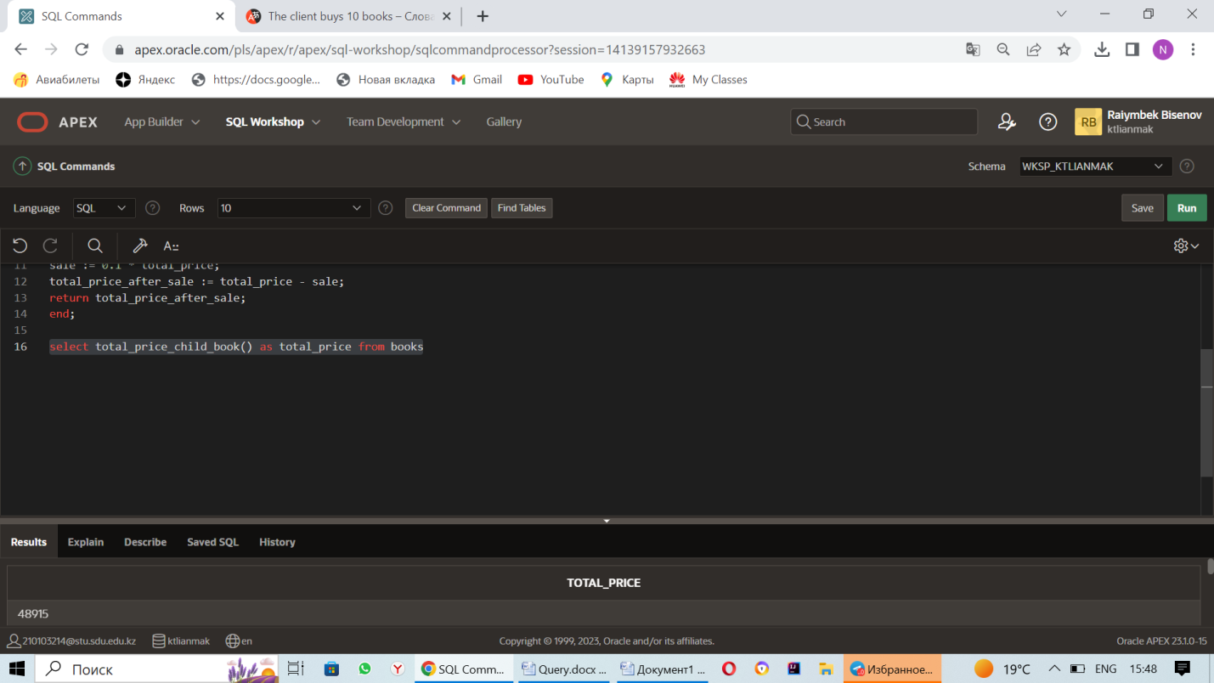

3. The function shows the number of records in the book table

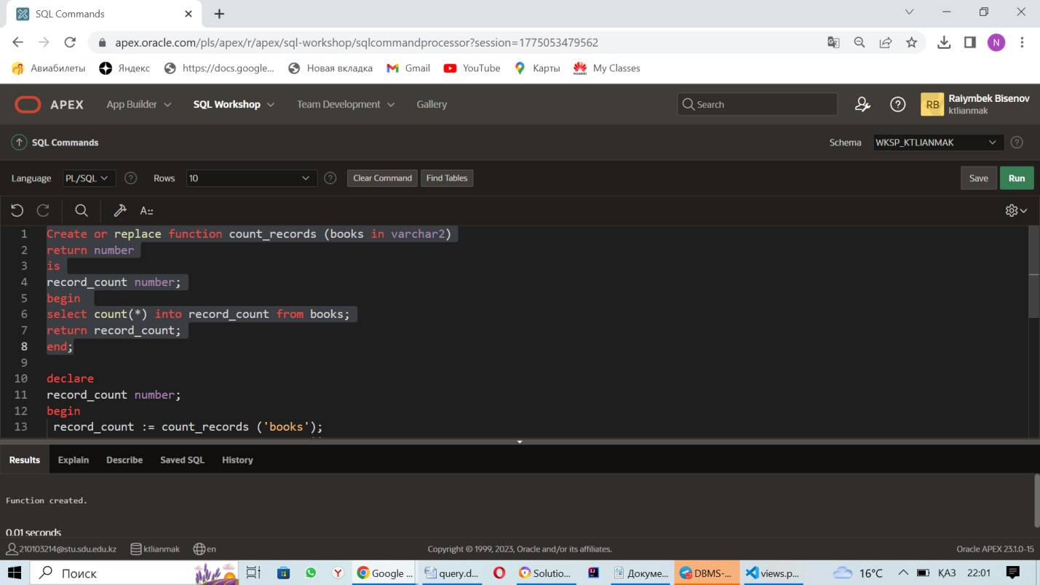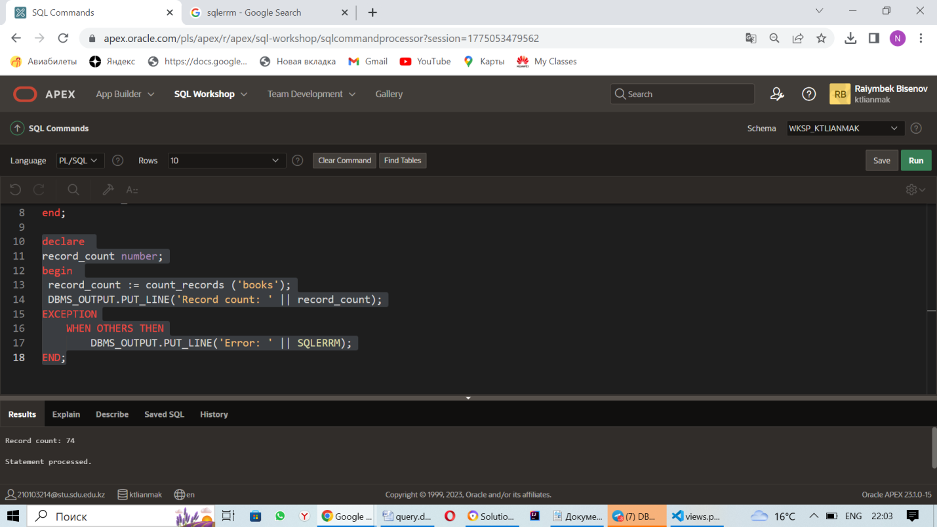

3. Function which counts the number of records

Create or replace function count_records (books in varchar2)

return number

is

record_count number;

begin

select count(*) into record_count from books;

return record_count;

end;

declare

record_count number;

begin

record_count := count_records ('books');

DBMS_OUTPUT.PUT_LINE('Record count: ' || record_count);

EXCEPTION

WHEN OTHERS THEN

DBMS_OUTPUT.PUT_LINE('Error: ' || SQLERRM);

END;